UX Check Results

# 1 : Visibility of system status

# Severity: 4

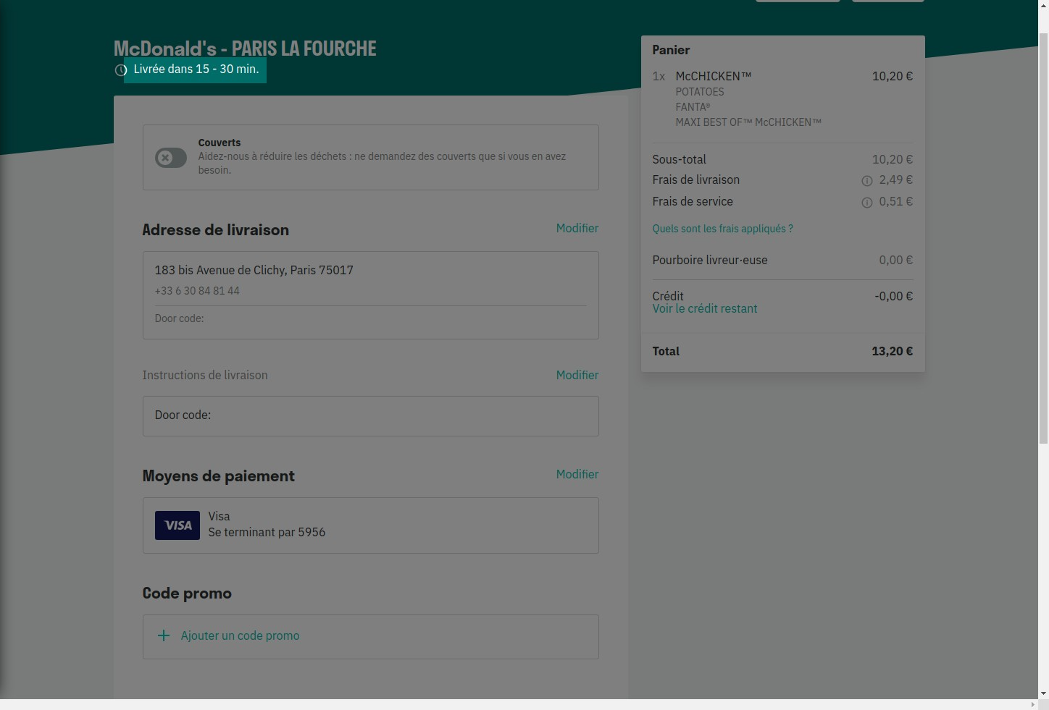

# Notes:

System status appears really when order is made. We can see deliver status and exact location.

# 2: Match between system and the real world

# Severity: 4

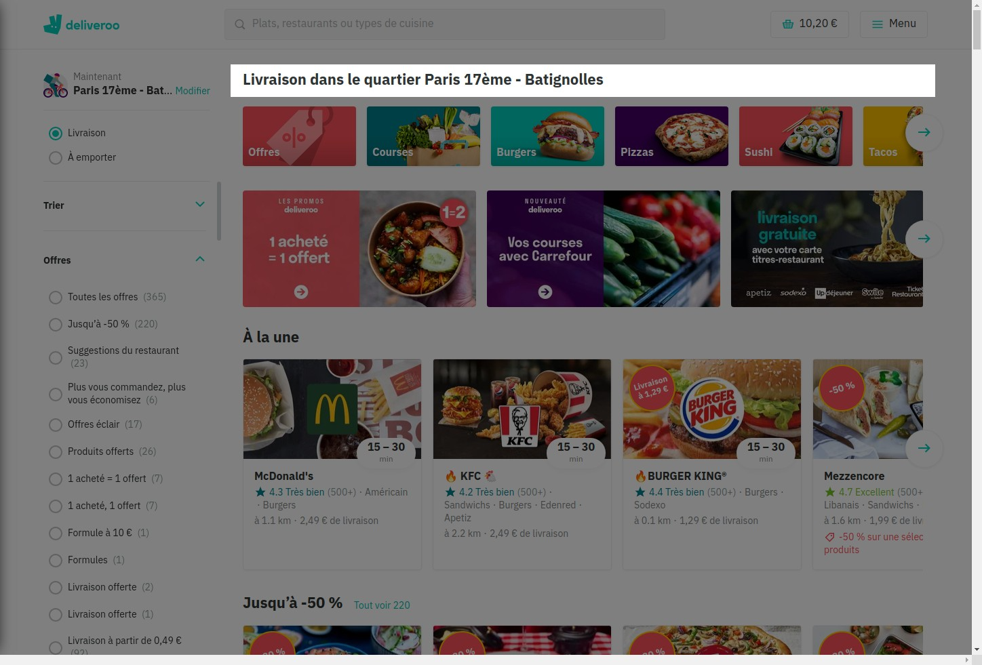

# Notes:

Information is clear and understanble to anyone, on top of the page.

# 3: User control and freedom

# Severity: 4

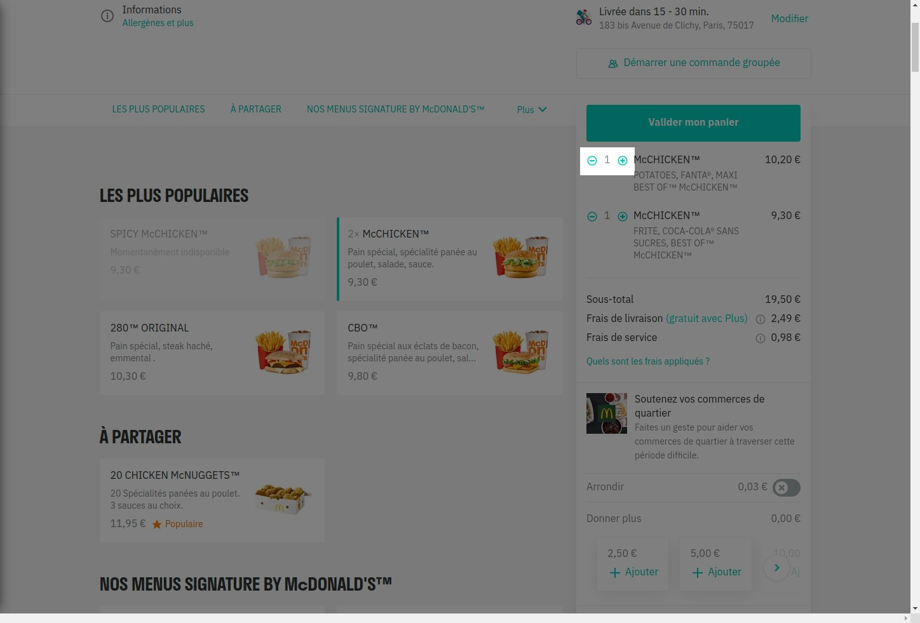

# Notes:

User can add or delete current order.

# 4 : Consistency and standards

# Severity: 4

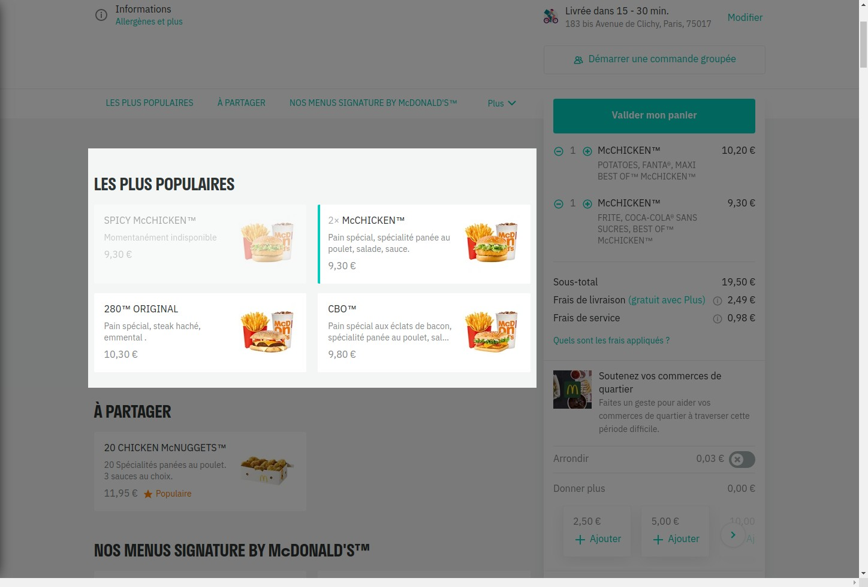

# Notes:

each box is consistent, design is the same

# 5 : Error prevention

# Severity: 3

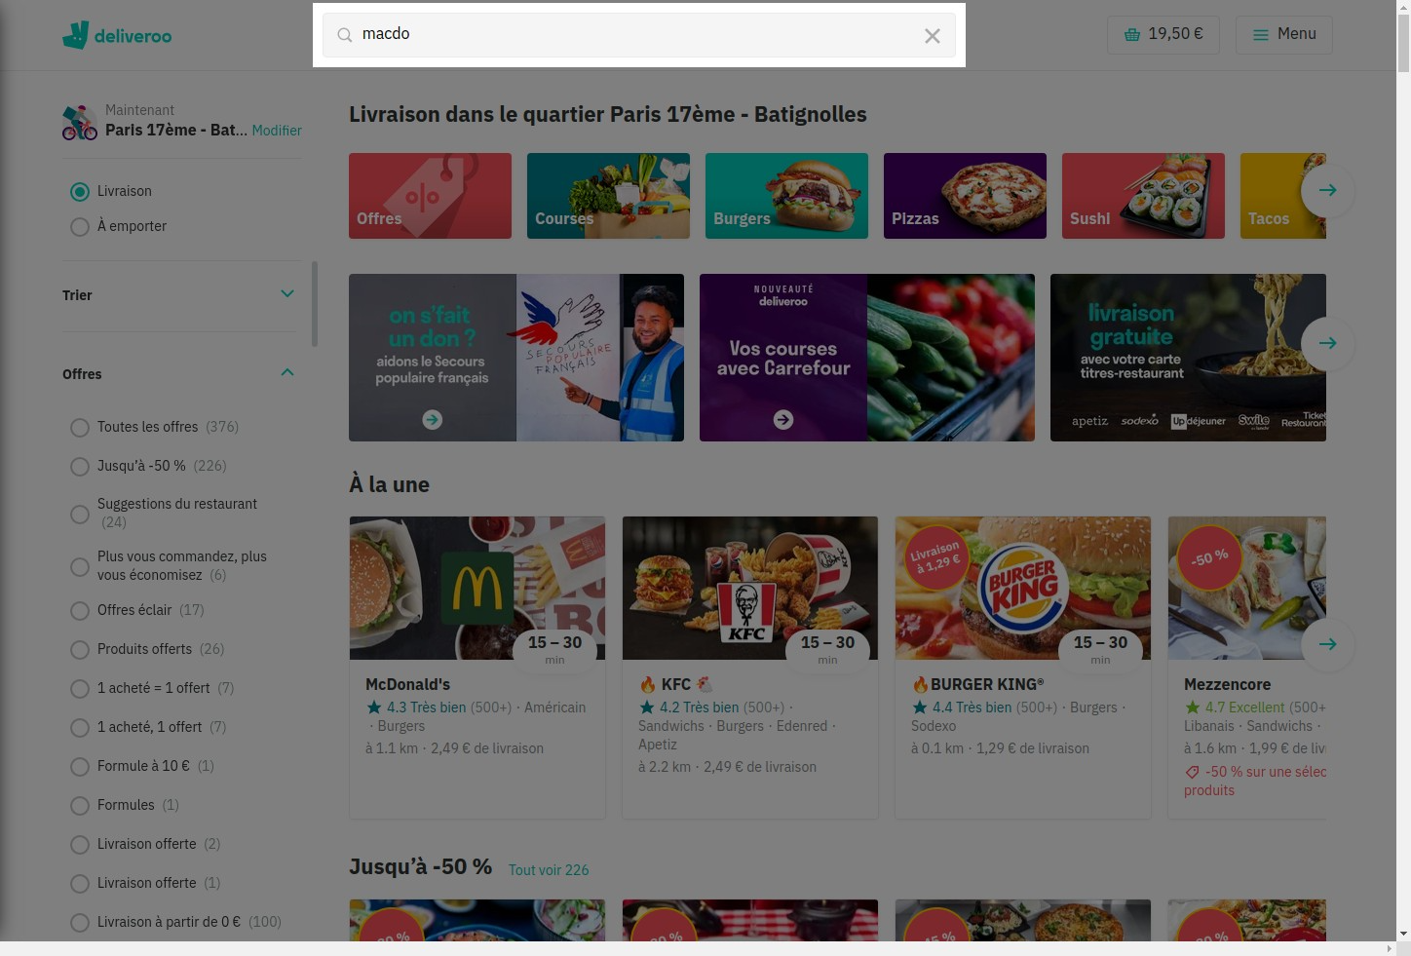

# Notes:

No prevention for this misspelling but suggestions under research

# 6 : Recognition rather than recall

# Severity: 4

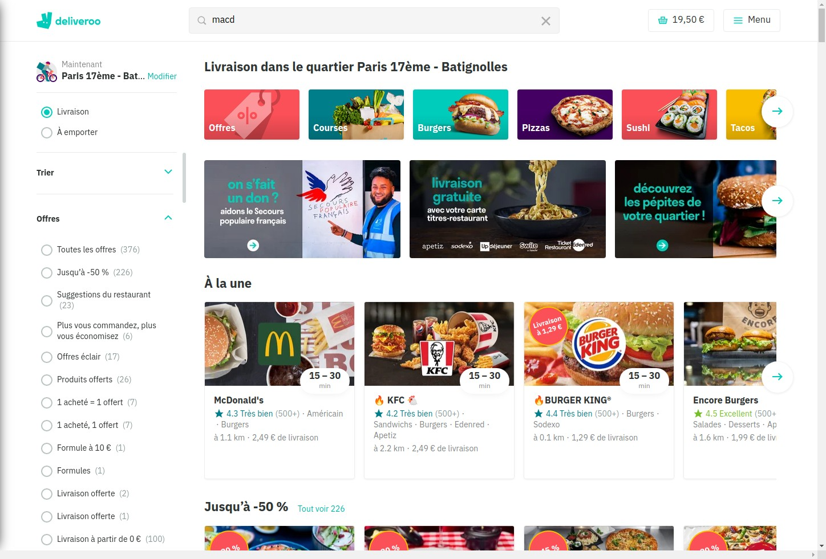

# Notes:

Recognition appears but could'nt screenshot it. Suggestion box disappears as soon as we click somewhere else. It allows to click faster on a picture user wants.

# 7 : Flexibility and efficiency of use

# Severity: 3

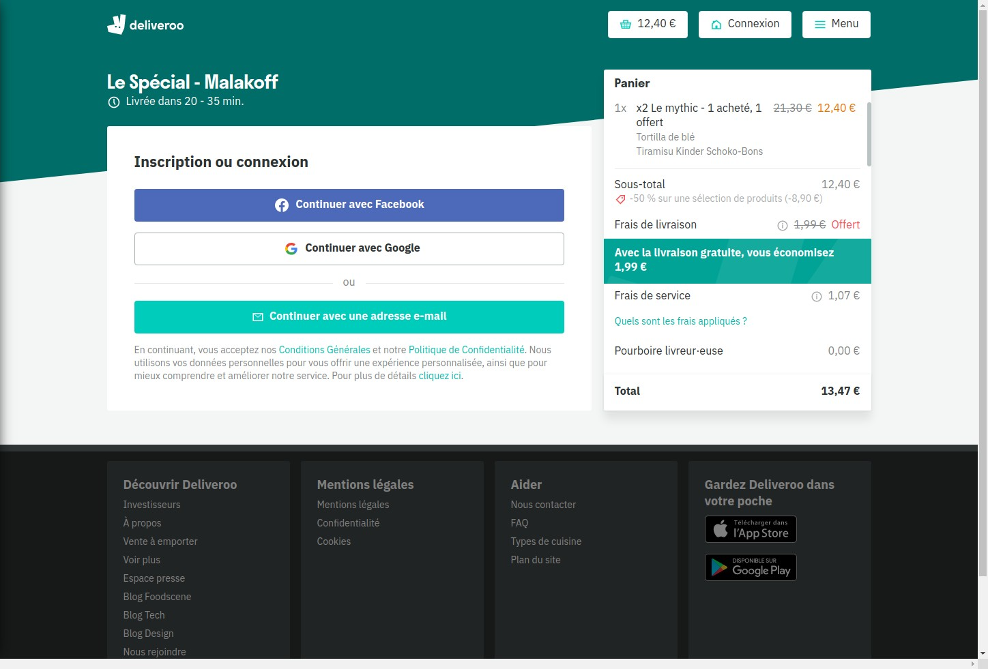

# Notes:

If user doesn't have an account, he can connect with google or facebook account so it makes it faster to subscribe. User who already

# 8 : Aesthetic and minimalist design

# Severity: 2

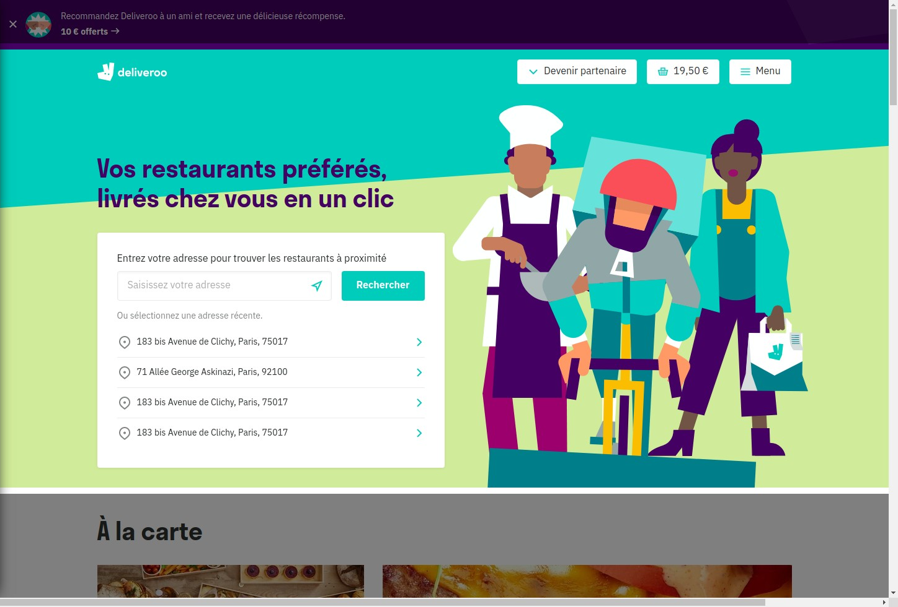

# Notes:

search bar for adress is visible even if we have a design behind. Home page leads to restaurants only nearby so it is a good point, user cannot look at restaurants he cannot order with.

Design is not minimalist, under the search block, we have a lot of pictures, information, promotions, everything is mixed and it can be confusing.

# 9 : Help recognize &amp; recover from errors

# Severity: 4

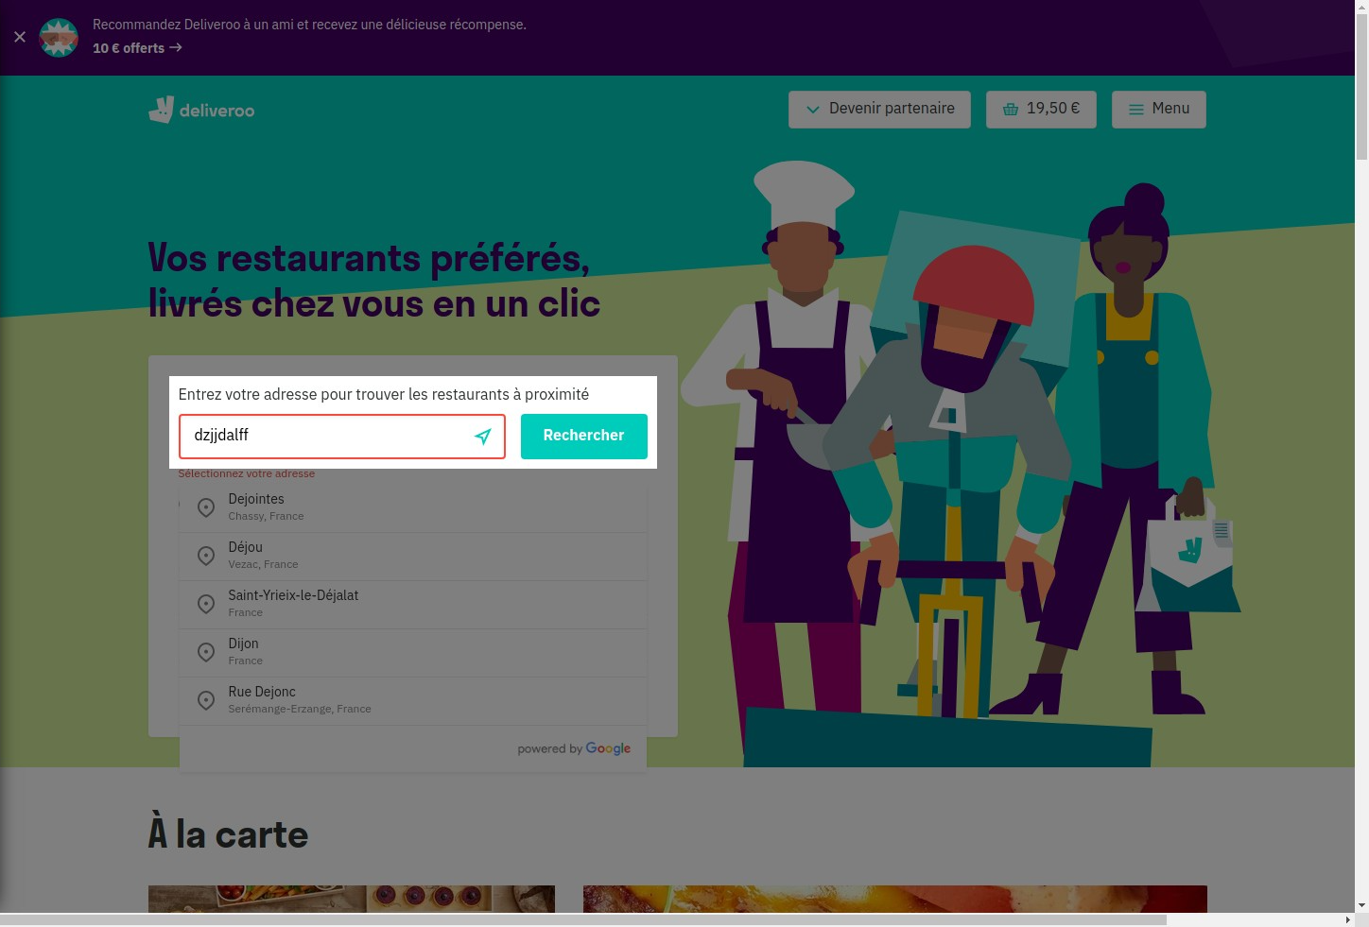

# Notes:

search bar turns red if the adress is not recognized, there are also suggestions underneath.

# 10 : Help and Documentation

# Severity: 3

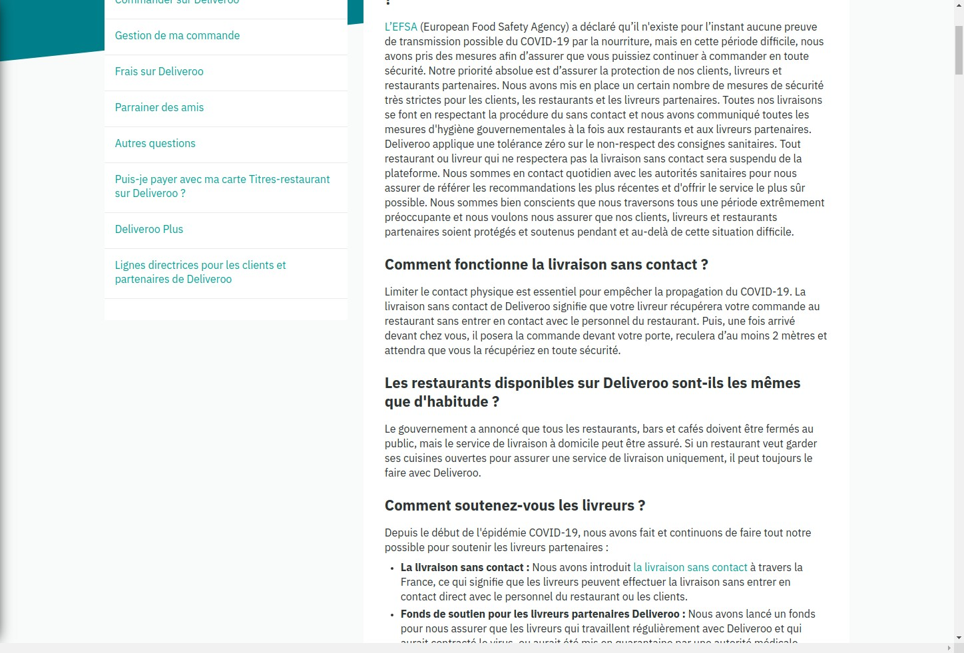

# Notes:

FAQ leads to instructions and information in case of problem. It is efficient, there is no need to contact customer service,. However if we do not have the answer in FAQ to our problem it is not easy to find how to contact customer service.